WEDE5020
POE, Proposal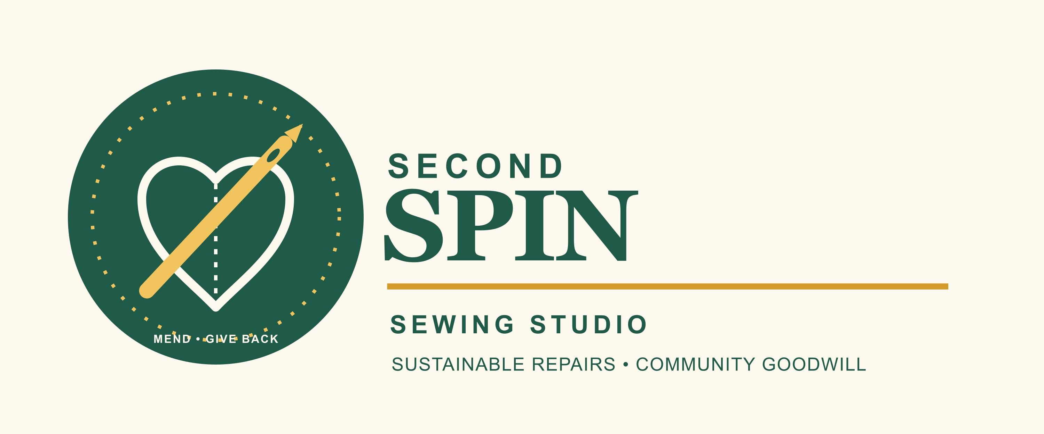
Naledi Samkelisiwe Zulu
ST10538234
GROUP 5.

PROPOSAL.
Website Project Proposal: Second Spin Sewing Studio
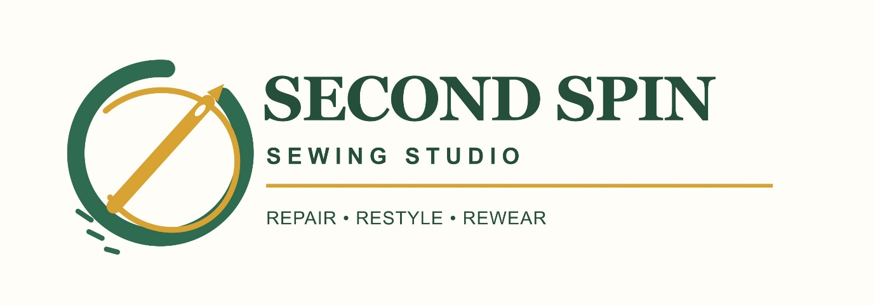
1. Organisation Overview
Second Spin Sewing Studio is a non-profit organisation (NPO) that repairs, alters, and upcycles clothing. It promotes sustainable fashion by helping people extend the life of their garments instead of throwing them away.
Its annual community initiative is “67 Minutes of Mend and Give Back,” held for Nelson Mandela Day. Volunteers use 67 minutes to repair donated clothing and prepare it for distribution to people in need.
The organisation’s mission is to reduce clothing waste, teach practical sewing skills, and support local communities through goodwill. Its vision is for a community where sustainable fashion and giving back are part of everyday life. The target audience includes students, volunteers, donors, residents, and people needing affordable repaired clothing.
2. Website Goals and Objectives
The website will promote:
- repairs,
- sewing workshops,
- donation drives,
- and the Mandela Day initiative.
This will ensure that visitors are able to easily find information, volunteer, donate clothing, or submit an enquiry. Success will be measured through volunteer registrations, donation pledges, workshop bookings, contact form submissions, and visits to the Mandela Day page.
3. Current Website Analysis
Second Spin Sewing Studio is a new fictional NPO and does not currently have a website. The proposed site will be clear, accessible, and mobile-friendly. It will avoid common problems such as unclear navigation, missing contact information, inaccessible content, and poorly designed forms.
4. Proposed Website Features and Structure
4.1 Sitemap
Web pages consist of the following:
- Home: Hero image, brief introduction, logo, navigation menu, and a call-to-action button.
- About Us: Organisation history, mission, vision, sustainability message, and team information.
- Services and Workshops: Clothing repairs, alterations, upcycling, workshop dates, and prices or suggested donations.
- Mandela Day Initiative: Information about the 67 Minutes of Mend and Give Back event, donations, and volunteering.
- Enquiry: A form for repair enquiries, volunteer applications, and sponsorship enquiries.
- Contact: Contact details, opening hours, contact form, and a map showing the Braamfontein workshop hub and Soweto collection point.

4.2 File and Folder Structure
  - Second Spin Sewing Studio
> Home.html
-about.html
-services.html
-mandela-day.html
-enquiry.html
- contact.html

>css
-style.css

>js
-script.js
-images
-logo.jpg
-repaired-clothes.jpg
- workshop.jpg

5. Design and User Experience – research on design principles
The website will use a warm design. Deep green will represent sustainability, gold will create a positive and hopeful feeling, and cream or white backgrounds will keep the content easy to read. Clear fonts such as Aptos and Arial will be used.
The layout will include consistent navigation, headings, short paragraphs, images, cards, and clear buttons. The website will work on mobile phones, tablets, and computers. Images will include alternative text, forms will have clear labels, and colours will have enough contrast for accessibility.

5.1 Information Hierarchy Chart and Low-Fidelity Wireframe

The information hierarchy places the logo, navigation, organisation purpose, and important volunteer call-to-action at the top of the Home page. Supporting information appears below, while contact details and additional links are placed in the footer.
6. Technical Requirements
The proposed domain name is secondspin.co.za, subject to availability. HTML will create the page structure using elements such as header, nav, main, and footer. CSS will provide colours, layout, and responsive design. JavaScript will validate forms and display confirmation messages.
7. Timeline and Milestones
- Week 1: Research, content planning, and sitemap
- Week 2: Wireframes, images, and page content
- Week 3: Create HTML pages and navigation
- Week 4: Add CSS styling and responsive design
- Week 5: Add JavaScript, forms, and testing
- Week 6: Final testing, corrections, and submission
8. Estimated Budget
The web development cost is R7 500. Basic hosting is estimated at R109 per month (R1 308 per year), while maintenance and content updates are estimated at R3 000 per year. The estimated first-year total is R11 808. However, development costs will not be charged for this student project.
9. References
Domains.co.za. Web Hosting Plans. Available at: https://www.domains.co.za/knowledgebase/billing/no-fixed-contract/
Nelson Mandela Foundation. Mandela Day. Available at: https://www.mandeladay.com/
Free Stock Photography. Available at: https://unsplash.com/
Licence. Available at: https://unsplash.com/license

